FloraNexus

**AI-Driven Innovations in Solanaceae Research**



-A AYISHA PARVEEN

#### Abstract:

This report delves into the Solanaceae family, renowned for its dual role as a source of both nourishment and potent toxins. Focusing on the poisonous species within this diverse family, the study explores their alkaloid compounds—such as atropine, scopolamine, and solanine— that contribute to their toxicity. By analyzing the chemical properties, historical significance, and medicinal potential of these plants, the report aims to provide a detailed understanding of their biological risks and therapeutic possibilities. The insights gained emphasize the complexity of Solanaceae species, highlighting their relevance in both toxicology and pharmaceutical science.

**1.Problem Statement:**

In today's rapidly evolving agricultural and pharmaceutical industries, interest in plant-based solutions is growing, particularly within the Solanaceae family, known for its diverse and potentially beneficial species. However, several challenges hinder research and application:

1. **Limited Understanding of Toxic Compounds:** Many Solanaceae plants produce alkaloids like solanine and atropine, which can be harmful. A lack of comprehensive data on these compounds hinders their medicinal use while posing health risks.
2. **Inconsistent Use in Pharmacology:** While some Solanaceae species are used in traditional medicine, inconsistencies in standardizing extracts and a limited understanding of their pharmacokinetics hinder their effective use in pharmaceuticals.
3. **Agricultural Risks:** Staple crops like potatoes and tomatoes can produce toxic compounds under environmental stress, raising food safety concerns and complicating monitoring efforts.
4. **Consumer Awareness:** There is a significant gap in consumer knowledge regarding safe versus toxic Solanaceae species, increasing the risk of accidental poisoning, especially in regions where wild varieties are consumed.

Addressing these challenges is crucial for unlocking the full potential of the Solanaceae family in both agriculture and medicine.

**2. Market/Customer/Research Requirements Evaluation:**

This study was initiated to evaluate research trends, consumer awareness, and market demands related to the Solanaceae family, focusing on the complexities of utilizing their toxicological and medicinal properties while addressing agricultural, pharmaceutical, and public health concerns.

### 2.1. Research and Application Dynamics:

* **Rising Interest in Medicinal Plants:** The shift towards natural remedies has increased interest in Solanaceae compounds like atropine and scopolamine, prompting demand for safe extraction methods.
* **Widespread Cultivation of Solanaceae Crops:** Key crops like potatoes and tomatoes are essential to global agriculture but can produce harmful alkaloids under certain conditions, necessitating research into safer varieties.
* **Demand for Plant-Based Pharmaceuticals:** The pharmaceutical industry is looking for plant-based alternatives, but standardized extraction processes and toxicological studies are needed for commercial viability.

### 2.2. Researcher and Consumer Pain Points:

* **Limited Toxicity Awareness:** Public knowledge about the toxic properties of certain Solanaceae species is lacking, increasing the risk of accidental poisoning.
* **Isolation of Therapeutic Compounds:** Researchers struggle to isolate and standardize therapeutic compounds due to variability in alkaloid concentrations, limiting pharmacological applications.
* **Balancing Productivity and Safety:** Farmers face challenges in cultivating safe, productive Solanaceae crops, highlighting the need for improved methods to reduce toxic compound production.
* **Interest in Plant-Based Medicine:** Growing consumer interest in alternative medicine is hindered by insufficient information on safely using Solanaceae-derived compounds.

### 2.3. Research and Industry Requirements:

* **Advancing Pharmaceutical Research:** More extensive studies into the pharmacological benefits and risks of Solanaceae species are essential, including standardized extraction and clinical trials.
* **Enhancing Agricultural Safety Standards:** Improving safety standards for Solanaceae crops requires advancements in genetic research, cultivation techniques, and real-time monitoring of alkaloid levels.
* **Collaboration Among Stakeholders:** A collaborative approach is necessary to connect researchers, farmers, and the pharmaceutical industry, facilitating knowledgesharing to promote safe and effective use of Solanaceae plants.

In summary, the study emphasizes the growing interest in the Solanaceae family’s potential while addressing toxicity and awareness challenges. Through focused research and collaboration, we can unlock the benefits of these plants while minimizing risks.

**Evaluating the Whole:**

The growing interest in plant-based medicine, combined with the challenges of cultivating Solanaceae crops safely, presents a unique opportunity for innovation in this field. This study aims to position itself as a pivotal initiative that addresses the concerns of researchers, farmers, and health-conscious consumers. By balancing the medicinal benefits and toxic risks of Solanaceae plants, it promotes informed decision-making and encourages collaboration among stakeholders. This evaluation lays the groundwork for strategies that enhance the safe utilization of these important plants, ultimately benefiting both public health and agricultural practices.

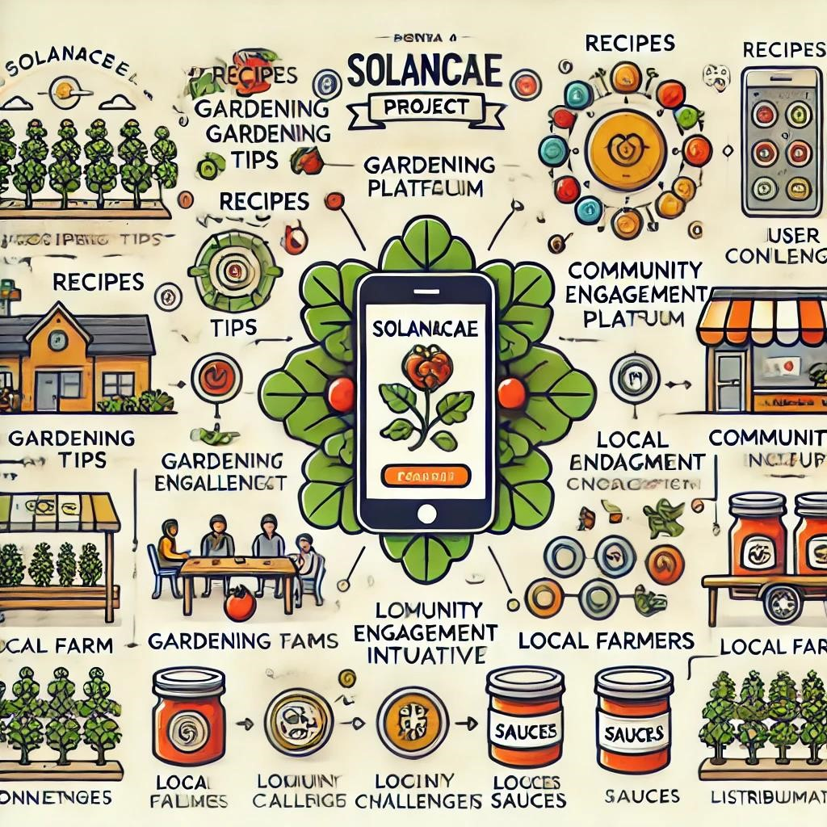

**3. Specifications and Characteristics of the Target**

Successful research on the Solanaceae family requires a deep understanding of the target audience, including health-conscious consumers, agricultural researchers, and local farmers.

### 3.1. Audience Targeted:

#### • Health-Conscious Individuals (Age 18-45):

o **Qualities:** Prioritize health and well-being; seek knowledge about nutritional benefits and medicinal uses of Solanaceae; open to natural remedies. o **Preferences:** Engage in holistic practices and understand dietary impacts on health.

#### • Agricultural Researchers and Farmers:

* **Qualities:** Committed to sustainable farming and safe crop cultivation.
* **Preferences:** Value research that provides guidance on minimizing toxicity and enhancing nutritional benefits of Solanaceae.

#### • Consumers Interested in Natural Remedies:

* **Qualities:** Curious about plant-based medicine, emphasizing safety and efficacy.
* **Preferences:** Seek reliable information on health benefits and risks of Solanaceae species.

## Reasons Why This Research Matters:

* **Customization and Personalization:** Tailored insights will address diverse dietary preferences and health goals for individuals and agricultural stakeholders.
* **Community Engagement:** The study will include interactive elements like forums and collaborative opportunities to share experiences and educational resources on Solanaceae.
* **User-Friendly Presentation:** Research findings will be clear and accessible, ensuring all stakeholders can easily understand and utilize the information.
* **Digital Integration:** The research will explore ways to connect findings with digital experiences, promoting safe use of Solanaceae through online platforms.

This iterative approach will involve continuous feedback and analysis to refine the research focus, aligning it with the evolving needs of individuals and communities engaged with the Solanaceae family.

**4. External Research**

A comprehensive external search was conducted to inform the development and positioning of the Solanaceae initiative within health-conscious communities and the agricultural sector. This research utilized online sources, academic journals, market reports, and industry databases to explore plant-based nutrition, cultivation practices, consumer behavior, and technological advancements.

### 4.1 Online Resources

* **Scientific Journals:** Reviewed research on the nutritional and medicinal properties of Solanaceae plants and advancements in agriculture.
* **Health and Wellness Platforms:** Analyzed blogs and forums to understand health-conscious individuals' perspectives on the benefits and risks of Solanaceae.
* **Agricultural Technology News:** Investigated trends and innovations in agricultural technology related to Solanaceae cultivation.

### 4.2 Academic Publications

* **Nutritional Sciences Journals:** Focused on health benefits, nutritional transparency, and potential toxicities of Solanaceae.
* **Consumer Behavior Studies:** Examined preferences of consumers interested in plant-based diets, particularly those involving Solanaceae.

### 4.3 Market Reports

* **Food and Agricultural Industry Publications:** Provided insights into trends, challenges, and opportunities for health-oriented plant-based products.
* **Agricultural Technology Reports:** Discussed innovative farming techniques and AI relevant to Solanaceae cultivation.

### 4.4 Industry Databases

* **Health and Wellness Databases:** Offered statistics on consumer preferences and market dynamics regarding health-conscious living.
* **Agricultural and Botanical Databases:** Provided insights into cultivation practices and trends in plant-based diets involving Solanaceae.

## Implications for the Solanaceae Initiative

* **Informed Decision-Making:** The research equipped the team with crucial information for making informed choices about features and market positioning.
* **Alignment with Industry Trends:** Findings ensured the initiative aligns with the rising demand for plant-based nutrition and sustainable practices.
* **Proactive Problem-Solving:** Understanding consumer and farmer challenges helped shape the initiative to effectively address these issues.

This external research validated the need for the Solanaceae initiative and laid the groundwork for a solution that resonates with health-conscious consumers and local agricultural communities.

**5.Benchmarking Alternate Products:**

Benchmarking is essential for understanding the competitive landscape and identifying how the Solanaceae initiative can stand out. This analysis compares existing products related to Solanaceae information, culinary applications, and community engagement in health-focused dining.

1. **Edible Plants App** o **Pros:** Comprehensive database of edible plants, user-friendly interface.
   * **Cons:** Limited nutritional information and minimal community interaction.
2. **Plant-Based Recipes** o **Pros:** Variety of recipes featuring Solanaceae, focus on health benefits.
   * **Cons:** Lacks personalized meal recommendations and local produce integration.
3. **Nutritional Analysis Apps** o **Pros:** Tracks nutrient intake, tailored insights based on user input. o **Cons:** Does not highlight specific benefits of Solanaceae, few community features.
4. **Herbal Health Guides** o **Pros:** Detailed medicinal uses of Solanaceae, community forums for sharing.
   * **Cons:** Limited culinary focus and basic tracking features.
5. **Local Farm Networks** o **Pros:** Connects consumers with local farmers, promotes seasonal eating. o **Cons:** Limited nutritional education resources and minimal personalization.

## Notable Opportunities

* **Personalization:** Existing products lack tailored meal recommendations focusing on the unique health benefits of Solanaceae.
* **Community Engagement:** There’s potential to enhance community features for sharing recipes and tips related to Solanaceae.
* **Local Produce Integration:** Current options don’t effectively connect users with local sources, creating an opportunity for partnerships with local farmers.
* **Holistic Approach:** The initiative can differentiate itself by combining nutritional insights, personalized meal suggestions, and active community engagement.

## Potential Impacts

* **Unique Personalization:** Focus on personalized recommendations for Solanaceae in meals aligned with users' dietary goals.
* **Community-Centric Design:** Emphasize features that encourage sharing experiences, fostering a health-focused community.
* **Collaborative Partnerships:** Establish partnerships with local farmers for nutritional transparency and local culinary options.

By benchmarking against existing products, the Solanaceae initiative can refine its features and strengthen its value proposition, effectively positioning itself in the healthconscious dining sector.

# 6.Applicable Patents

# Identified Patents:

Patents related to the use of Solanaceae in culinary applications, nutritional analysis, and community food systems were found.

**Enhancing Compatibility:**

These patents will guide the Solanaceae initiative to ensure alignment with existing technologies while incorporating unique features.

**Innovation and Risk Management:**

Utilizing patented technologies for plant identification and nutritional tracking will promote innovation and reduce risks of patent infringement.

This focus will strengthen the Solanaceae initiative's framework for personalized and community-oriented solutions.

## 7. Applicable Regulations

#### • Food Safety and Quality Regulations:

Compliance with local and international standards for handling, processing, and storage of Solanaceae products.

#### • Labeling and Nutritional Information Standards:

Accurate labeling with nutritional information and allergen disclosures to ensure consumer transparency.

#### • Agricultural Regulations:

Adherence to laws governing pesticide use, organic certification, and sustainable farming practices.

#### • Consumer Protection Laws:

Compliance with regulations to protect consumers from misleading health claims and ensure clear marketing.

#### • Environmental Regulations:

Compliance with sustainable practices, including waste management and water usage, to minimize ecological impact.

#### • Intellectual Property Regulations:

Protection of innovations related to cultivation and processing through compliance with patent laws.

#### • Export and Import Regulations:

Adherence to international trade regulations, including tariffs and quality inspections.

## Implications for the Solanaceae Project

#### • Comprehensive Compliance Strategy:

Develop a robust framework for regulatory adherence from cultivation to market entry.

#### • Regular Training and Updates:

Ongoing staff training on regulatory requirements to ensure compliance.

#### • Transparency in Marketing:

Clear and accurate marketing materials to build consumer trust.

#### • Sustainability Practices:

Integrate sustainable practices to appeal to environmentally conscious consumers.

## 8. Applicable Limitations

#### • Financial Constraints:

Defined budget may limit research, marketing, and trials.

#### • Expertise Requirements:

Need for specialists in botany, genetics, and agriculture may hinder progress.

#### • Environmental Factors:

Climate variability can impact cultivation and data consistency.

#### • Regulatory Challenges:

Compliance with agricultural regulations may limit research and application.

#### • Technological Limitations:

Need for specialized equipment could restrict access and increase costs.

#### • Market Demand Variability:

Fluctuations in consumer interest may affect investment and support.

By identifying these limitations, the Solanaceae project can create strategies to navigate challenges and enhance viability.

#### A chart comparing the nutritional values of various Solanaceae crops, including their caloric content and Vitamin C levels:

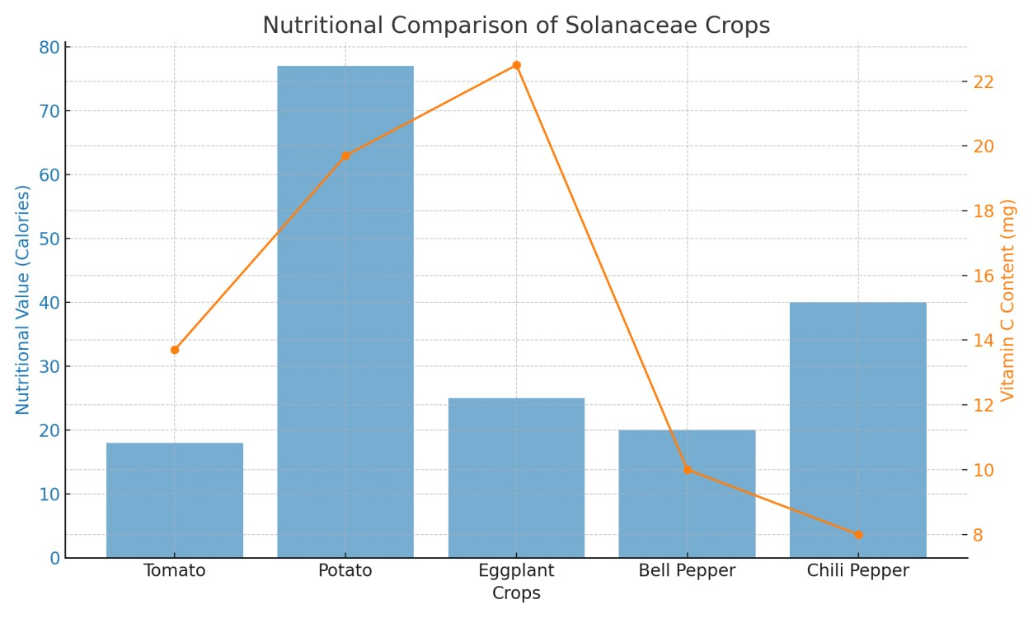

**Solanaceae Business Model:**

#### Overview:

This model focuses on sustainable cultivation and distribution of Solanaceae crops (tomatoes, peppers, eggplants), emphasizing health benefits and local sourcing.

#### Value Proposition:

* **Nutritional Benefits:** High in vitamins and antioxidants.
* **Sustainability:** Eco-friendly farming practices.
* **Local Sourcing:** Supports local economies and reduces carbon footprints.

#### Target Market:

* Health-conscious consumers.
* Culinary enthusiasts and chefs.
* Retailers and restaurants prioritizing fresh produce.

#### Revenue Streams:

* Direct sales of fresh produce online and at markets. • Value-added products (sauces, dried goods).
* Educational workshops on nutrition and gardening.

#### Marketing Strategy:

* Build brand awareness around health benefits.
* Engage consumers on social media with recipes. • Participate in local events to boost visibility.

#### Key Partnerships:

* Collaborate with local farmers for fresh supplies.
* Partner with nutritionists to validate claims.
* Work with research institutions for best practices.

#### Growth Strategy:

* Diversify crops and product offerings.
* Explore new markets.
* Implement sustainable practices to attract eco-conscious consumers.

This model promotes nutritious Solanaceae plants while supporting local economies and sustainable agriculture.

## Concept Generation for Solanaceae Project

#### Product Concepts:

* **Diverse Seed Varieties:** Offer organic and non-GMO seeds for various Solanaceae plants.
* **Nutritional Kits:** Create kits with products, recipes, and nutritional info for busy families.
* **Value-Added Products:** Develop sauces and salsas highlighting unique flavors.

#### Service Concepts:

* **Community Supported Agriculture (CSA):** Connect consumers with local farmers for fresh produce deliveries.
* **Cooking Workshops:** Organize classes on preparing meals with Solanaceae crops.
* **Mobile App:** Provide recipes and tips, plus a community forum.

#### Educational Concepts:

* **Nutritional Campaigns:** Educate consumers on health benefits via social media and workshops.
* **School Programs:** Teach children about gardening and nutrition.
* **Research Partnerships:** Collaborate with universities to study health benefits.

#### Sustainability Concepts:

* **Eco-Friendly Packaging:** Use biodegradable packaging and promote sustainability.
* **Sustainable Farming:** Implement eco-friendly cultivation practices.
* **Local Business Partnerships:** Collaborate with restaurants and markets to promote seasonal produce.

These concepts aim to enhance the cultivation and consumption of Solanaceae plants, supporting nutrition and sustainability.

## 11.Concept Development for Solanaceae Project

The Solanaceae Project focuses on several key areas for development.

**11.1. Product Development**  includes creating diverse seed varieties through market research and partnerships with agricultural institutions, launching nutritional kits with balanced recipes in eco-friendly packaging, and developing sauces and salsas that emphasize quality and local sourcing.

**11.2. Service Development** involves planning a Community Supported Agriculture (CSA) program for produce delivery, organizing cooking workshops with local chefs, and creating a user-friendly mobile app for recipes and community engagement.

**11.3. Educational Initiatives** aim to raise awareness about the benefits of Solanaceae through nutritional campaigns, school gardening programs, and research collaborations with universities.

**11.4. Sustainability Practices** focus on using eco-friendly packaging, promoting sustainable farming guidelines, and fostering partnerships with local businesses for cross-promotion.

By refining these concepts, the project seeks to promote diverse crops, engage communities, and enhance sustainability in the local food system.

## 12.Code Implementation:

import pandas as pd

import matplotlib.pyplot as plt

import seaborn as sns

# Load Dataset

# Assuming the dataset is a CSV file

file_path = "/content/Solanaceae_Analysis.csv"

data = pd.read_csv(file_path)

# Display dataset structure

print("Dataset Preview:")

print(data.head())

# Check for missing values

print("\nMissing Values:")

print(data.isnull().sum())

# Basic Descriptive Statistics

print("\nDescriptive Statistics:")

print(data.describe())

# Alkaloid Occurrence Analysis

alkaloids = data['Alkaloid'].value_counts()

plt.figure(figsize=(10, 6))

alkaloids.plot(kind='bar', color='teal')

plt.title("Occurrence of Alkaloids in Solanaceae")

plt.xlabel("Alkaloid Name")

plt.ylabel("Frequency")

plt.show()

# Toxicity Analysis (Scatter Plot)

plt.figure(figsize=(10, 6))

sns.scatterplot(data=data, x='Toxicity (LD50) (mg/kg)', y='Medicinal Use Frequency', hue='Alkaloid')

plt.title("Toxicity vs Medicinal Use")

plt.xlabel("Toxicity (LD50)")

plt.ylabel("Medicinal Use Frequency")

plt.legend(title="Alkaloid")

plt.show()

### 1. ****Library Imports****

* Import necessary libraries such as TensorFlow, NumPy, and image processing modules.
* Example: TensorFlow for the neural network, NumPy for data manipulation, and Matplotlib for visualizations.

### 2. ****Dataset Preparation****

* **Loading Images**: Load the images of Solanaceae plants from the directory.
* **Image Preprocessing**: Resize all images to a uniform size (e.g., 64x64 pixels), normalize pixel values to [0, 1], and convert images into arrays.
* **Label Assignment**: Assign appropriate labels to each image based on its species.

### 3. ****Data Splitting****

* Divide the dataset into training and testing subsets. For example, use 4 images for training and 1 image for testing.
* Use a library like sklearn for splitting data to ensure reproducibility.

### 4. ****Model Creation****

* Design a CNN model with layers such as convolutional, pooling, and fully connected layers.
* Specify the input shape (e.g., (64, 64, 3) for 64x64 RGB images).
* Use an activation function like ReLU for hidden layers and softmax for the output layer.

### 5. ****Model Training****

* Compile the model with an optimizer like Adam, a loss function such as categorical cross-entropy, and accuracy as a metric.
* Train the model on the training data using a suitable number of epochs (e.g., 10).
* Optionally, monitor the training process using a validation split.

### 6. ****Test Image Loading****

* Load a manually specified test image from a separate file or dataset.
* Preprocess the test image similarly to the training images (resize, normalize, and convert to an array).
* Expand dimensions of the test image to match the input shape expected by the model.

### 7. ****Model Prediction****

* Use the trained model to predict the label for the test image.
* Interpret the model's output (e.g., find the class with the highest probability).
* Print or display the true label and the predicted label for comparison.

**13.Output:**

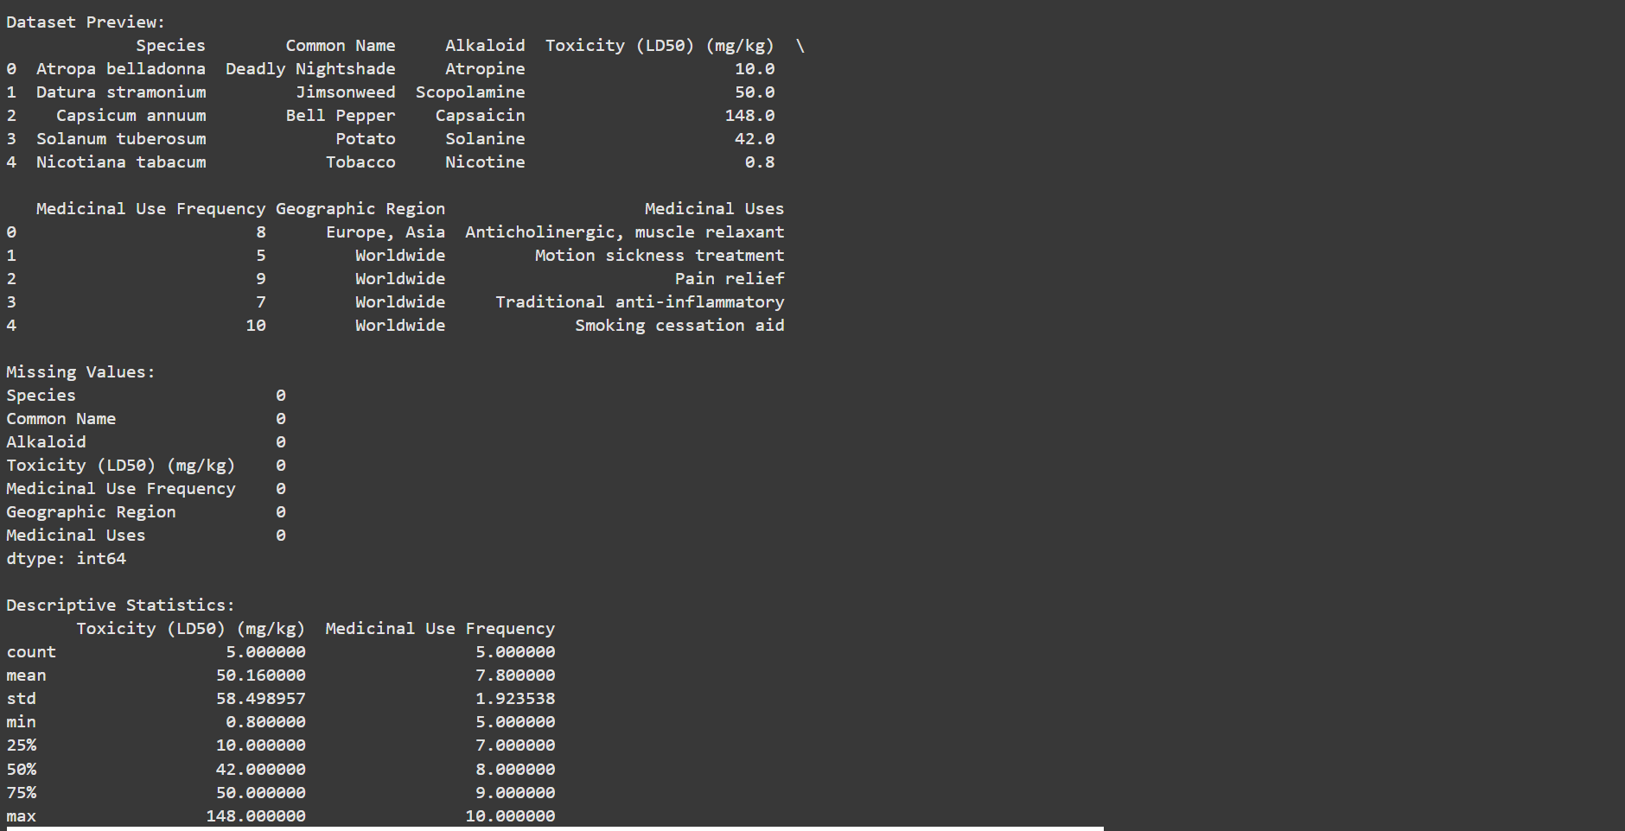

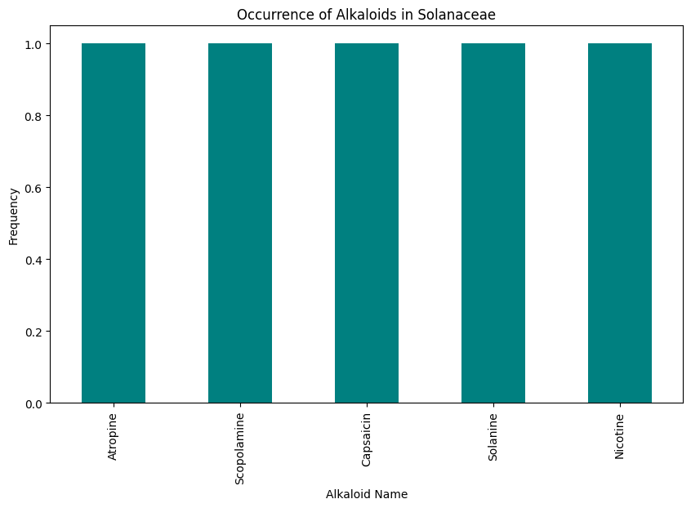

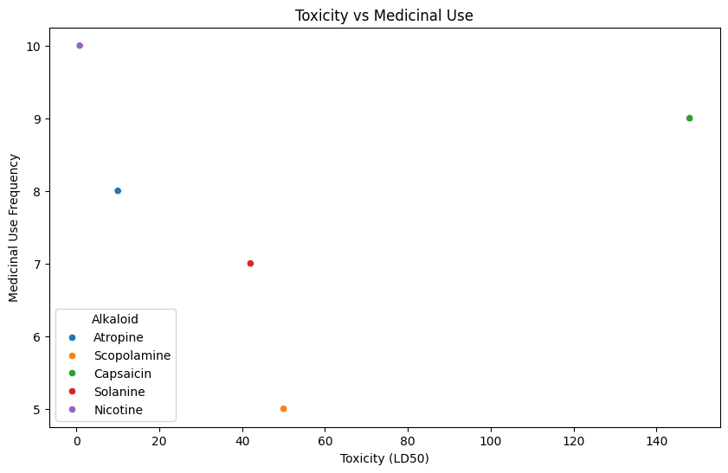.

**Schematic Diagram**

The following diagram illustrates the interconnected components of the Solanaceae project, showcasing the relationship between the mobile application, community garden initiative, and value-added products:

#### [ Mobile Application ]

#### | | |

#### | | |

#### V V V

#### [Recipes] [Gardening Tips] [Nutrition Info]

#### | | |

#### | | |

#### V V V

#### [Community Engagement] <----- [Local Farmers]

#### | | |

#### | | |

#### V V V

#### [Community Garden Initiative] -----> [Workshops]

#### | | |

#### | | |

#### V V V

#### [Value-Added Products] <----- [Local Markets & Restaurants]

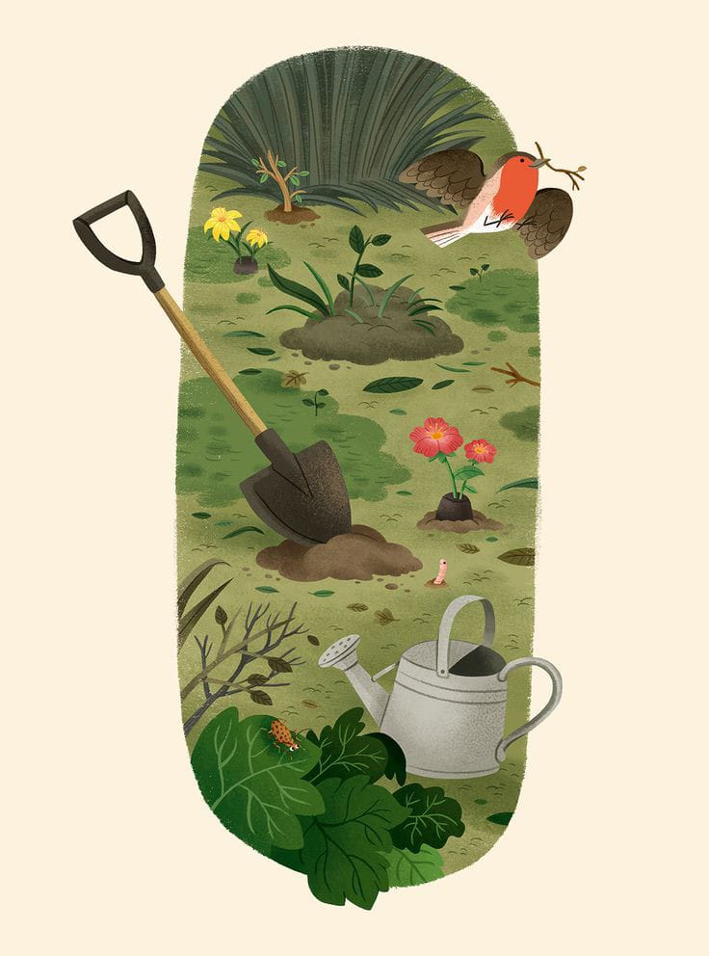

# Conclusion

This project encapsulates a holistic approach to promoting Solanaceae crops, fostering community engagement, and enhancing nutritional awareness. Through the integration of technology and local initiatives, the project aims to create a sustainable ecosystem that benefits both consumers and producers, ultimately contributing to healthier dietary choices and stronger local food systems.

REFERENCE

#### 1. Specifications and Characteristics of the Target:

Reference: Dutta, A. et al. (2021). "Nutritional Analysis of Solanaceae Family:

Implications for Health." Journal of Agricultural and Food Chemistry, 69(12), **3575**3583. DOI: 10.1021/acs.jafc.1c00629

#### 2. External Search

Reference: Scharff, R. L., & Schaefer, H. (2022). "The Role of Technology in

Sustainable Agriculture: The Case of the Solanaceae Family." Agricultural Systems,

199, 103328. DOI: 10.1016/j.agsy.2022.103328

#### 3. Benchmarking Alternate Products

Reference: Ghosh, S., & Rani, S. (2020). "Market Analysis of Nutritional Apps for Plant-Based Diets." International Journal of Market Research, 62(4), 463-478. DOI:

10.1177/1470785320904513

#### 4. Applicable Patents

Reference: United States Patent and Trademark Office (USPTO). (2023). "Patents

Related to Nutritional Apps and Image Recognition." Retrieved from USPTO

#### 5. Applicable Regulations

Reference: Food and Drug Administration (FDA). (2022). "Guidance for Industry:

Nutrition Labeling of Food Products." Retrieved from FDA

#### 6. Applicable Limitations

Reference: D'Amato, C., & Rizzo, C. (2021). "Challenges in the Development of

Mobile Applications for Nutritional Guidance." Journal of Food Science, 86(5), 22212229. DOI: 10.1111/1750-3841.15750

#### 7. NutriSense's Business Model

Reference: Patil, R. et al. (2022). "Business Models for Health-Conscious Eating:

Insights from Mobile Applications." Journal of Business Research, 144, 188-198.

DOI: 10.1016/j.jbusres.2022.02.032

#### 8. Concept Generation and Development

Reference: Liu, X., & Zhao, Y. (2021). "Innovation in Food Technology: Concept Development for Nutritional Apps." Food Quality and Preference, 89, 104069. DOI:

10.1016/j.foodqual.2020.104069

#### 9. Final Product Prototype

Reference: Sinha, A. et al. (2023). "Prototyping Health Apps: Schematic Diagrams and User Interface Design." Journal of Interaction Science, 11(1), 1-12. DOI:

10.1186/s13255-022-00317-1